Appendix I
Appendix Figure 1: Distribution of Total QALY Estimates from all simulation runs using multiplicative disutility count
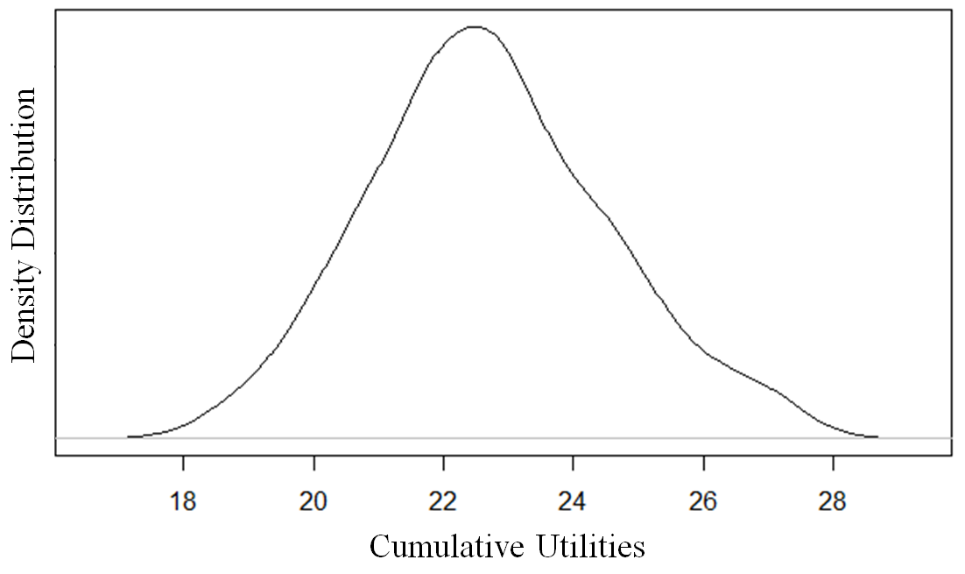
Appendix Figure 2: Survival Curve of General Canadian Population vs. Extreme Preterm Survivors to Discharge
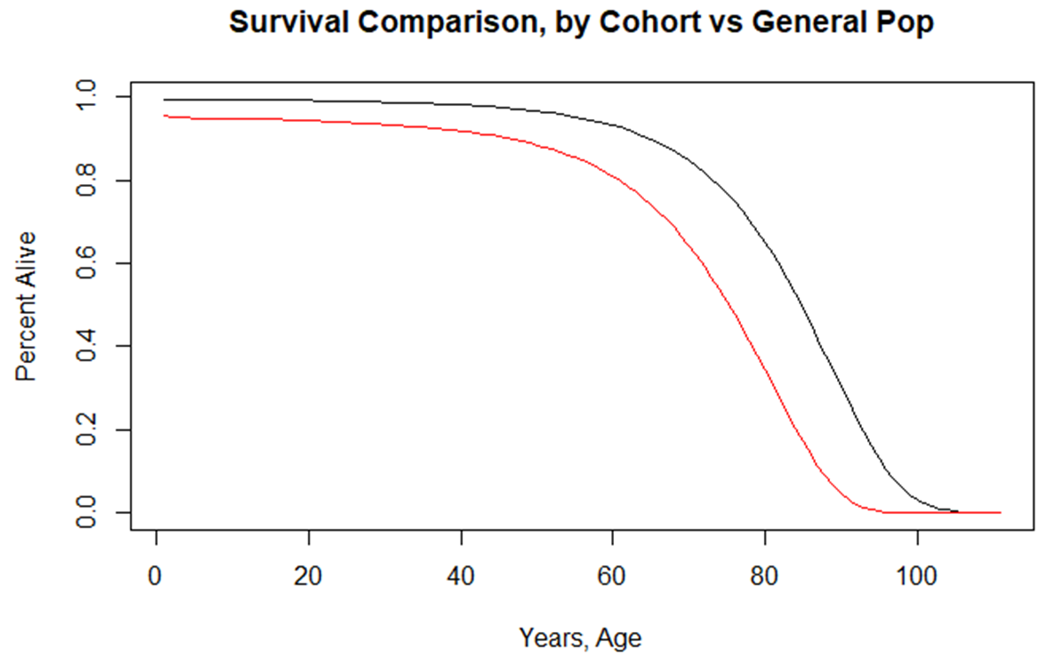

Appendix Figure 3: Density of Individual Simulant Lifetime Costs
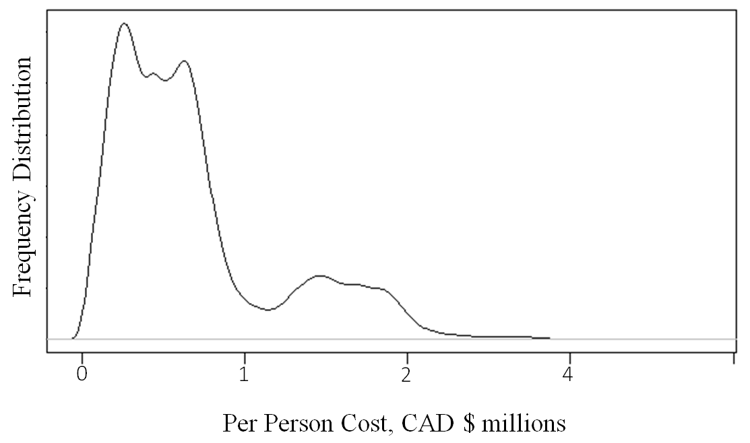
Appendix Figure 4: Density of Individual Simulant Lifetime QALYs
